QUESTION

What is your ip-address?

what is your subnet mask?

What is your Network address?

What is your Broadcast address?

Committed by :- Satish Gautam

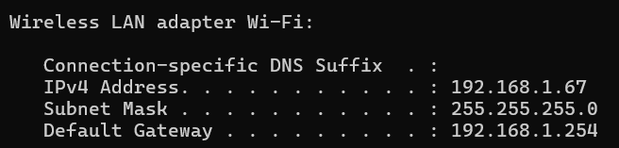

From the given information of IP Adress and Subnet Mask, we have to calculate

Network address and Broadcast address:

Convert IP Address and Subnet Mask to Binary:

IP Address: 192.168.1.67

11000000.10101000.00000001.01000011

Subnet Mask: 255.255.255.0

11111111.11111111.11111111.00000000

To calculate Network Address:

Perform a Bitwise and operation between IP Adress and Subnet Mask:

The Network address is: 11000000.10101000.00000001.00000000

In Decimal: 192.168.1.0

To calculate Broadcast Address:

The inverted subnet mask is: 00000000.00000000.00000000.11111111

Perform a bitwise OR operation between the network address and the inverted subnet mask:

The Broadcast Address (in binary) is: 11000000.10101000.00000001.11111111

The Broadcast Address (in decimal) is: 192.168.1.255